INFRACTIONS:
• Interference
• Not clearing
hurdle properly:
Hooks hurdle
Runs around
Knocks over hurdle
with hand
• Not finishing in
assigned lane
3
6
9
4
5
10
11
12
INFRACTIONS:
• Interference
• Not starting or
finishing in
assigned lane
Finish

Start 100 m
1
4
3
6
2
5
100-METER SPRINT
7
8
9
11
10
12
Page 7
Finish

Start 100 m
Start 110 m

1
2
110- & 100-METER HURDLES
Also watch for one athlete’s hurdle interfering with another athlete, and for clearing the hurdle in the wrong lane.
7
8
8
7
8
1
5

INFRACTIONS:
• Lane violation
• USATF: 1 step,
either foot
• NCAA: 2
consecutive steps
of any feet
• NFHS: 3
consecutive steps
of any feet
• Interference
Finish

Start 200 m
200-METER SPRINT
6
2
4
3
1
5
7
8
9
10
11
12
INFRACTIONS:
• Lane violation
• USATF: 1 step,
either foot
• NCAA: 2
consecutive steps
of any feet
• NFHS: 3
consecutive steps
of any feet
• Interference
Finish

Start 400 m
1
2
3
4
5
7z
400-METER SPRINT
6
10
11
8
12
9
Page 8
INFRACTIONS:
• Interference
• Not clearing
hurdle properly
[See 100/110
hurdles.]

• Lane violation
Finish

Start 400 m
400-METER HURDLES
(& 300-m & 200-m hurdles)
1
2
3
4
9
6

7
8
5
10
11
12
Page 9

INFRACTIONS:
• Interference
• Cutting in
before
breakline
• Lane violation
before
breakline
Finish

Start 800 m
800-METER RUN
(could have alley start; coned every 4 m to breakline)
If in lanes, cones out at start; remove from inside lanes after the 1st pass of runners.
Breakline
3
8
1
2
5
4
7
6
9
10
11
12

Breakline or cut-in points (used at end of the first turn in the 800-m run; and only the second runner in the 4x400-m relay). Small orange or red cones are placed such that if the athlete hits the cone, he/she has crossed the line before the breakline or into the lane to the left and violated the rules. – Rule 160.8(c): “. . . Small markers, such as cones or prisms 5cm x 5cm and no more than 15cm high, preferably of a different color from the breakline and lane lines, shall be placed on the lane lines immediately before the intersection of the lane lines and the breakline.”

The cones should be placed as shown for all eight or nine lanes: Lane 1

Lane line
Breakline

Direction of runners Lane 2

Lane line
Lane 3

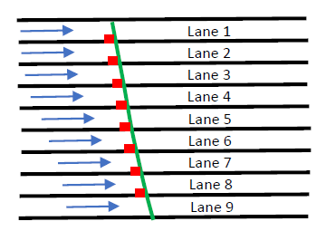
Page 6

Page 5

Placements of Hurdles Relative to Track Markings

Hurdle Placement - Rule 168.9: “The hurdles shall be so placed on the track that the feet of the hurdles shall be on the side of the approach by the competitor. The hurdle shall be so placed that the edge of the bar nearest the approaching hurdler coincides with the track marking nearest the approaching hurdler.”

track marking

Direction of hurdlers

edge of bar

Placements of Cones at the Breakline

INFRACTIONS:
• Interference
• Paced by lapped
or about-to-be-
lapped runner
or by person
not in the race
• Didn’t run in direct line on final straightaway unless another in path
Finish
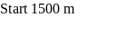
Start 1000 m, 3000 m, 5000 m
Start 2000 m, 10,000 m
1
2
3
4
6
5
1500-METER & LONGER RUNS
7
8
9
10
11
12

INFRACTIONS:
• Doesn’t clear
hurdle
• Hooks hurdle
(leg or foot
beside hurdle
below top
horizontal
plane)
• Interference

Finish
Start 3000 m Steeplechase
Start 2000 m
Water
Jump
STEEPLECHASE
2
1
5
3
4
6
7
8
9
10
11
12
start
start
#1 moves to direct athletes to the water jump with green flag in right hand (signaling with red or yellow flag in left hand to not stay on the track).
Page 10
INFRACTIONS:
• Passing baton
before or after
relay zone
• Lane violation
• Starting run
before relay
zone
• Interference
• Gloves, tape,
substance on hand
Finish
Relay Zone 1
Relay Zone 2
Relay Zone 3

Start 400 m
4 x 100-METER RELAY
1
6
2
5
3
4
Standard markings = yellow triangles
Tape: USATF = one piece, 5 x 40 cm (2 x 16 in)
NCAA = two pieces, 2 in wide x <width of lane
NFHS = designated by Games Cmte
7
8
9
10
11
12

Zone chiefs signal to starter - raise white flags when ready.
4 X 200
Exch 1 = red
Exch 3 = blue

16
13
15
14
#4,5, & 6 write. Others remove tape.
Page 11

INFRACTIONS:
• Passing baton
before or after
relay zone
• Starting run
before relay
zone
• Lane violation
through 3rd
turn
• Cutting in
before breakline
• Interference
Finish
Breakline
Relay Zone
Start 400 m
4 x 400-METER RELAY
Standard markings = blue triangles
[USATF Rule 170.14: 3rd & 4th runners order
as at 200 meters.]
1
2 (at break; otherwise at the L)
6 (beginning of the relay zone)
5
3
4
1st pass = no cones; 2nd pass with cones; 3rd & 4th pass = no cones.
start
start
L
7
8
9
10
11
12

Organization/Age Group Distance Number Height To 1st Between Last to Finish Standard Color

WOMEN Order
Junior High 100 10 30” 13 m 8.5 m 10.5 m
High School 100 10 33” 13 m 8.5 m 10.5 m
NCAA, USATF 100 10 33” 13 m 8.5 m 10.5 m
Junior High 200 5 30” 50 m 35 m 10 m
High School 300 8 30” 45 m 35 m 10 m
NCAA, USATF 400 10 30” 45 m 35 m 40 m
NCAA, USATF 3000 SC 28 (7 water) 30” 5 jumps/lap after fin. line passed 1st time; water jump 4th BLACK
Girls 11-12 80 8 30” 12 m 7.5 m 15.5 m #8
Girls 13-14 100 10 30” 13 m 8.5 m 10.5 m YELLOW #6
Girls 15-16/Women 17-18 100 10 33” 13 m 8.5 m 10.5 m YELLOW #3,4
Girls 13-14 200 5 30” 20 m 35 m 40 m
Girls 15-16/Women 17-18 400 10 30” 45 m 35 m 40 m
Girls 13-16/Women 17-18 2000 SC 18 (5 water) 30” 5 jumps/lap after fin. line passed 1st time; water jump 4th BLACK
MASTERS WOMEN
25-39 100 10 33” 13 m 8.5 m 10.5 m
40-49 80 8 30” 12 m 8 m 12 m
50-59 80 8 30” 12 m 7 m 19 m
60+ 80 8 27” 12 m 7 m 19 m
25-49 400 10 30” 45 m 35 m 40 m
50-59 300 7 30” 50 m 35 m 40 m (same locations as 400)
60-69 300 7 27” 50 m 35 m 40 m (same locations as 400)
70+ 200 5 27” 20 m 35 m 40 m (same locations as 400)
All ages 2000 SC 18 (5 water) 30” 5 jumps/lap after fin. line passed 1st time; water jump 4th BLACK
[from USATF Best Practices]
Page 4

Hurdle Placement and Height Comparison – Outdoor Meets
Page 3

Organization/Age Group Distance Number Height To 1st Between Last to Finish
Standard color

MEN Order
Junior High 110 10 33” 13.72 m 9.14 m 14.02 m BLUE
High School & U20 110 10 39” 13.72 m 9.14 m 14.02 m BLUE
NCAA, USATF 110 10 42” 13.72 m 9.14 m 14.02 m BLUE
Junior High 200 5 30” 50 m 35 m 10 m
High School 300 8 36” 45 m 35 m 10 m
NCAA, USATF 400 10 36” 45 m 35 m 40 m
NCAA, USATF 3000 SC 28 (7 water) 36” 5 jumps/lap after fin. line passed 1st time; water jump 4th BLACK
Boys 11-12 80 8 30” 12 m 7.5 m 15.5 m #7
Boys 13-14 100 10 33” 13 m 8.5 m 10.5 m YELLOW #5
Boys 15-16/Men 17-18 110 10 39” 13.72 m 9.14 m 14.02 m BLUE #1,2
Boys 13-14 200 5 30” 20 m 35 m 40 m
Boys 15-16/Men 17-18 400 10 36” 45 m 35 m 40 m
Boys 13-14,15-16/Men 17-18 2000 SC 18 (5 water) 36”(30” for 13-14) 5 jumps/lap after fin. line passed 1st time; water jump 4th BLACK
MASTERS MEN
25-49 110 10 39” 13.72 m 9.14 m 14.02 m
50-59 100 10 36” 13 m 8.5 m 10.5 m
60-69 100 10 33” 12 m 8 m 16 m
70-79 80 8 30” 12 m 7 m 19 m
80+ 80 8 27” 12 m 7 m 19 m
25-49 400 10 36” 45 m 35 m 40 m
50-59 400 10 33” 45 m 35 m 40 m
60-79 300 7 30” 50 m 35 m 40 m (same locations as 400)
80+ 200 5 27” 20 m 35 m 40 m (same locations as 400)
25-59 3000 SC 28 (7 water) 36” 5 jumps/lap after fin. line passed 1st time; water jump 4th BLACK
60+ 2000 SC 18 (5 water) 30” 5 jumps/lap after fin. line passed 1st time; water jump 4th BLACK
__________________________________________________________________________________________________

KEEPING TRACK OF HEATS FOR YOUTH MEETS (Girls/Boys)
Age Divisions: 8 & under 9-10 11-12 13-14 15-16 17-18 (young women/young men)
HEAT 1 2 3 4 5 6 7 8 9 10
Page 12
HEAT 1 2 3 4 5 6 7 8 9 10

RELAY EXCHANGE ZONE

No
run-up zone

It is an infraction if both athletes have their hands on the baton after the exchange zone.
It is an infraction if both athletes have their hands on the baton before the exchange zone.
Exchange zone
30 meters in 4x100 &
4x200
20 meters in 4x400 & longer

The exchange must take place in this zone.

Direction of runners

It is an infraction if the runner accelerates/starts running outside the exchange zone.
____________________________________________________________________________________________________________

Page 13
Example of Completed Umpire’s Incident/Infraction Report

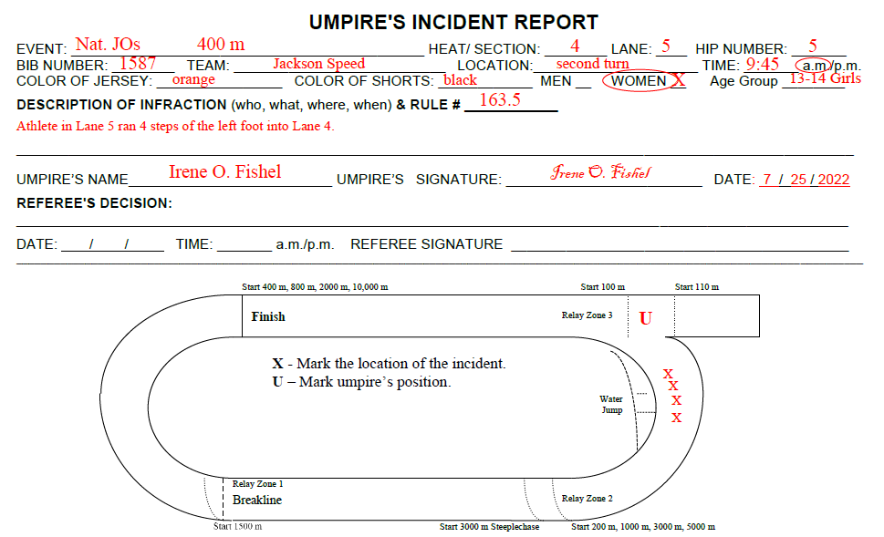

Observation

The umpire should be in a position to observe the competitors within her/his line of sight as the field passes, the hurdles are cleared or the baton is exchanged. Therefore, generally observation should take place on the outside of the track.

Forms and Reporting Observations

- The incident/infraction report form should answer all the basic questions (who, what, where, when, and how) as well as providing room for the needed signatures.
- Each umpire who sees the incident/infraction should complete a report form.
- Only those specifically assigned to the umpiring task or requested by the Referee to observe all of the competitions may submit an incident/infraction report form that may result in a disqualification.
- When the umpire decides to report a violation, she/he raises a yellow flag. Upon completion of the event and without consultation with any other, the umpire completes an incident/infraction report form and waits for the Chief Umpire or Referee. The Referee may ask clarifying questions or for collaborating observations from other umpires. If in the Referee’s judgment there is not indisputable evidence of a violation, there may be a decision to take no action.
- When a potential violation occurs and immediately following the competition of the event, the umpire should seek to capture as much information as possible to describe the “who, what, where, why and how” of her/his observation.

Follow-up

Immediately following that day’s meet or during a major break in the competition, the umpires should meet with the
Chief Umpire and Referee to debrief on the meet and lessons learned.

Page 2

USATF Umpiring Best Practices – Content Outline
Page 1
(September 2009; also see detailed information in the USATF Umpire Manual / Monograph)

Role of the Umpire

To help ensure fairness for all competitors, umpires closely observe all track competitions. Though often inadvertent or a result of ignorance of the rules, violations can either harm a competitor’s opportunities or give unfair advantage to one over others. Should the umpire observe a possible violation of the applicable rules governing that competition, a formal observation report is to be filed through the Chief Umpire to the Track Referee. The Track Referee will determine if a rules violation has occurred and take an appropriate action consistent with the applicable rules.

Prior to the Event

- Umpires report to a designated meeting area not less than 30 minutes prior to the first running event. Each umpire should bring a clipboard, appropriate rule book, pencil and be dressed appropriately for the meet and weather conditions.
- Chief Umpire conducts an organizing meeting to distribute flags and reporting forms, assign individual umpires to cover specific sectors, review the schedule, discuss movements within sector to best observe each event, review the reporting procedure, review key rules to be applied and any special provisions established by Games Committee, and provide any other information needed for the umpires to perform their duties. This may include a walk of the track to review markings.
- Umpire should become thoroughly familiar with the sector of the track they are assigned to cover and follow the instructions of the Chief Umpire regarding the best points of observation for each event.

Location

To perform this role, there must be a minimum of four umpires and each umpire should be assigned by the Chief Umpire to a location that best permits full observation of the track by the umpiring crew. In assigning the location, priority should be given to covering the four curves and appropriate movement to be in the best position to observe every competitor in every event. This may require the umpire to position themselves in the stands.
__________________________________________________________________________________________

Alley Start (generally for 1,500-m and longer runs with a large number of competitors) - Cones are placed on the Lane 4/5 line (so that the runners starting in the outside lanes don’t hit the cone) from the start to the breakline at the end of the first turn. – Rule 162.18: “In races that do not start in lanes, competitors may be divided into two groups with one group of approximately 65 percent of the competitors on the regular arced starting line and the other group on a separate arced starting line marked across the outer half of the track. The outer group shall run as far as the end of the first turn on the outer half of the track.” - Rule 160.9: “The separate arced starting line referred to in Rule 162.18 shall be marked in such a way that all of the competitors shall run the same distance. Also, an arced breakline shall be marked at the beginning of the following straight to indicate to the athletes of the outer group where they are permitted to join the competitors using the regular starting line. Small markers, as in Rule 160.8(c), shall be placed at intervals not exceeding 4m along the inside lane boundary of the outer group from their start to the break line.”
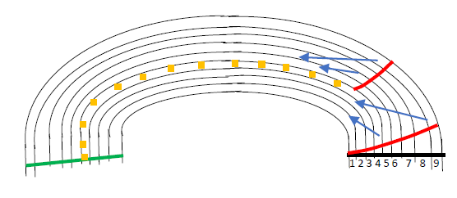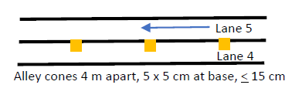
Two alley start lines
Finish line
Breakline

Page 14

NOTES, including names and positions of other officials
Page 15

Outdoor Combined Events
Men’s (including Masters) Pentathlon: Long Jump, Javelin, 200-m, Discus, 1500-m
Women’s (including Masters) Pentathlon: 100-m Hurdles, High Jump, Shot Put, Long Jump, 800-m
Men’s (including 15-16 Boys) Decathlon, Day 1: 100-m, Long Jump, Shot Put, High Jump, 400-m
Men’s (including 15-16 Boys) Decathlon, Day 2: 110-m Hurdles, Discus, Pole Vault, Javelin, 1500-m
Women’s (including 15-16 Girls) Decathlon, Day 1: 100-m, Discus, Pole Vault, Javelin, 400-m
Women’s (including 15-16 Girls) Decathlon, Day 2: 100-m Hurdles, Long Jump, Shot Put, High Jump, 1500-m
Women’s Heptathlon, Day/Part 1: 100-m Hurdles, High Jump, Shot Put, 200-m; Day/Part 2: Long Jump, Javelin, 800-m
Girls’ 9-10 Triathlon: Shot Put, High Jump, 200-m Boys’ 9-10 Triathlon: Shot Put, High Jump, 400-m
Girls’ 11-12 Pentathlon: 80-m Hurdles, Shot Put, High Jump, Long Jump, 800-m
Boys’ 11-12 Pentathlon: 80-m Hurdles, Shot Put, High Jump, Long Jump, 1500-m
Girls’ 13-14 Pentathlon: 100-m Hurdles, Shot Put, High Jump, Long Jump, 800-m
Boys’ 13-14 Pentathlon: 100-m Hurdles, Shot Put, High Jump, Long Jump, 1500-m

Sprint Medley Relay (1-1-2-4): 100-m, 100-m, 200-m, 400m
Super Sprint Medley Relay (2-2-4-8): 200-m, 200-m, 400-m, 800-m
Swedish Relay (1-2-3-4): 100-m, 200-m, 300-m, 400-m
Distance Medley Relay (3-1-2-4 laps): 1200-m, 400-m, 800-m, 1600-m


UMPIRE’S BOOKLET

J.G. & E.M. Price, with help from R. Hooper, S.D. Petrelli, G. Kleeman, T. Sligh, R. Rauch, and K. Skyles, 13 January 2023

