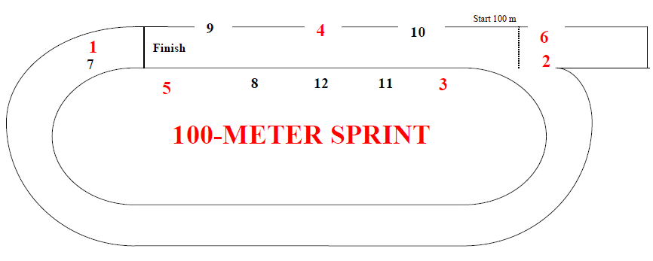

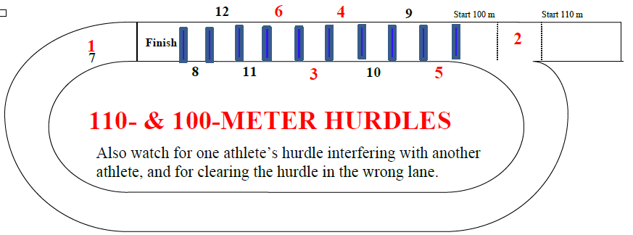

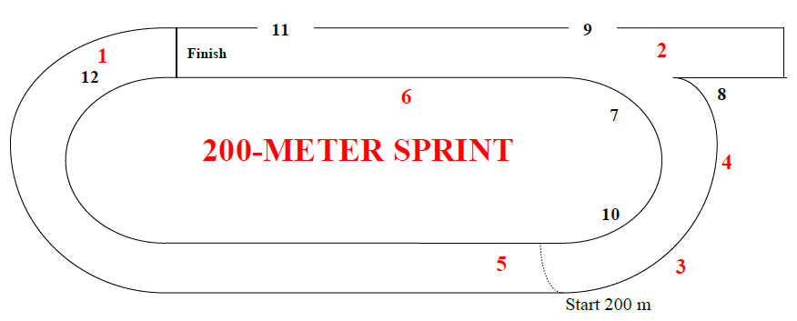

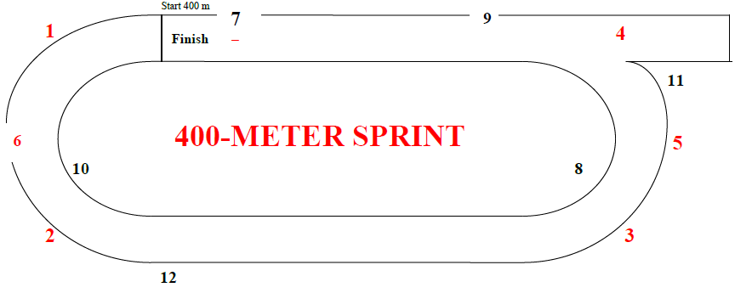

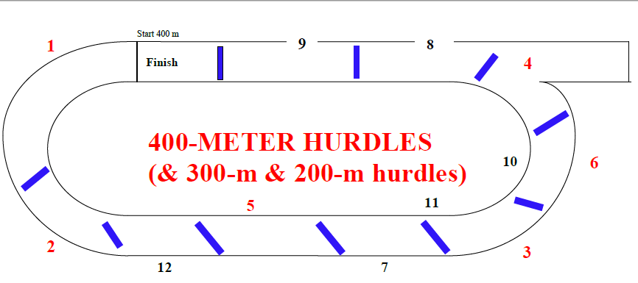

Umpires’ Positions
USATF-Pacific v.13January2023

Hurdle Infractions:
Foot or leg below top of hurdle (hooks hurdle) [168.3(a)] [SC 169.4(b)]
Didn’t jump each hurdle (ran around or hand pushed over) [168.3] [SC 169.4]
Deliberately knocked down hurdle [168.3(b)]
Didn’t stay in lane (interfered {with whom?} or shortened race) [168.3]
Stepped to one side or the other of water jump or SC hurdle [SC 169.4(a)]
Interference – who did it and who was impacted?
Jostled, ran across, or obstructed so as to impede another competitor [163.4]
Assistance – who provided it to whom? [144.2]
Pacing by persons not participating or lapped or about to be lapped [144.3(a)]
Possession or use by athlete of video, audio, or communication device [144.3(b)]
Aided by technology or appliance [144.3(c)] Personal assistance marker [163.2]
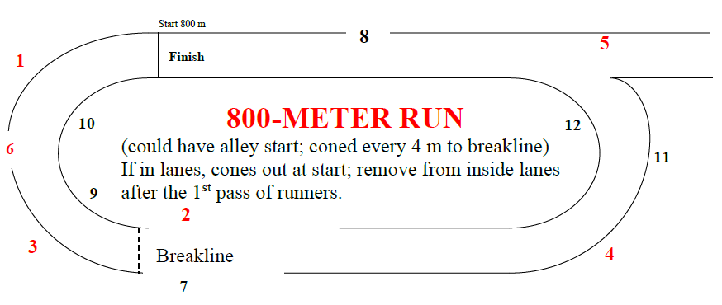

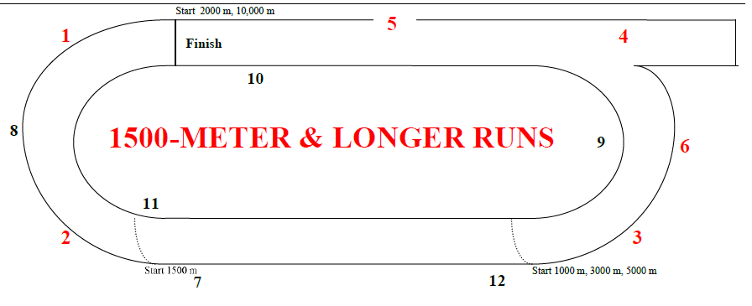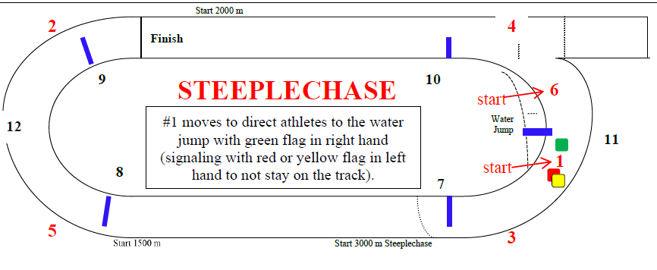

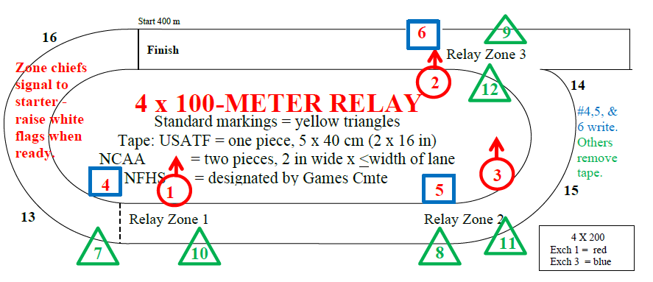
[Rule 170.5]
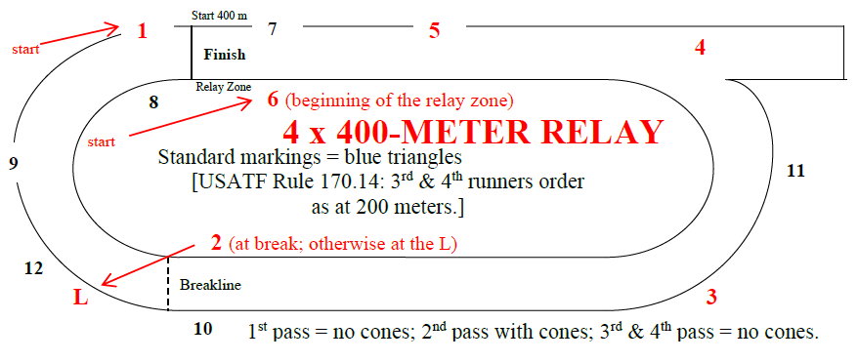
Lane Violations:
USATF: 1 step of either foot on or over inside line [163.5]
NCAA: 2 consecutive steps of any feet
NFHS: 3 consecutive steps of any feet
Cut in before breakline [163.5]
Did not finish in correct lane [163.5]
Didn’t run in direct line on final straightaway, unless in path [163.3]
Relay Violations:
Exchanged baton before or after zone [170.17]
Accelerated before zone [170.13]
Incorrect recovery of dropped baton [170.16]
Impeded/did not maintain lane position [170.18]
Assisted outgoing runner by pushing [170.19]
Baton not carried by hand [170.16]
Failure to participate [142.3], except youth [302.2(g)]
Left track voluntarily and returned [163.6(a)] Unsporting conduct [125.10]

BLANK]
Hurdle Placement and Height Comparison – Outdoor Meets

Organization/Age Group Distance Number Height To 1st Between Last to Finish
Standard color

MEN Order
Junior High 110 10 33” 13.72 m 9.14 m 14.02 m BLUE
High School & U20 110 10 39” 13.72 m 9.14 m 14.02 m BLUE
NCAA, USATF 110 10 42” 13.72 m 9.14 m 14.02 m BLUE
Junior High 200 5 30” 50 m 35 m 10 m
High School 300 8 36” 45 m 35 m 10 m
NCAA, USATF 400 10 36” 45 m 35 m 40 m
NCAA, USATF 3000 SC 28 (7 water) 36” 5 jumps/lap after fin. line passed 1st time; water jump 4th BLACK
Boys 11-12 80 8 30” 12 m 7.5 m 15.5 m #7
Boys 13-14 100 10 33” 13 m 8.5 m 10.5 m YELLOW #5
Boys 15-16/Men 17-18 110 10 39” 13.72 m 9.14 m 14.02 m BLUE #1,2
Boys 13-14 200 5 30” 20 m 35 m 40 m
Boys 15-16/Men 17-18 400 10 36” 45 m 35 m 40 m
Boys 13-14,15-16/Men 17-18 2000 SC 18 (5 water) 36”(30” for 13-14) 5 jumps/lap after fin. line passed 1st time; water jump 4th BLACK
MASTERS MEN
25-49 110 10 39” 13.72 m 9.14 m 14.02 m
50-59 100 10 36” 13 m 8.5 m 10.5 m
60-69 100 10 33” 12 m 8 m 16 m
70-79 80 8 30” 12 m 7 m 19 m
80+ 80 8 27” 12 m 7 m 19 m
25-49 400 10 36” 45 m 35 m 40 m
50-59 400 10 33” 45 m 35 m 40 m
60-79 300 7 30” 50 m 35 m 40 m (same locations as 400)
80+ 200 5 27” 20 m 35 m 40 m (same locations as 400)
25-59 3000 SC 28 (7 water) 36” 5 jumps/lap after fin. line passed 1st time; water jump 4th BLACK
60+ 2000 SC 18 (5 water) 30” 5 jumps/lap after fin. line passed 1st time; water jump 4th BLACK
__________________________________________________________________________________________________

Organization/Age Group Distance Number Height To 1st Between Last to Finish Standard Color

WOMEN Order
Junior High 100 10 30” 13 m 8.5 m 10.5 m
High School 100 10 33” 13 m 8.5 m 10.5 m
NCAA, USATF 100 10 33” 13 m 8.5 m 10.5 m
Junior High 200 5 30” 50 m 35 m 10 m
High School 300 8 30” 45 m 35 m 10 m
NCAA, USATF 400 10 30” 45 m 35 m 40 m
NCAA, USATF 3000 SC 28 (7 water) 30” 5 jumps/lap after fin. line passed 1st time; water jump 4th BLACK
Girls 11-12 80 8 30” 12 m 7.5 m 15.5 m #8
Girls 13-14 100 10 30” 13 m 8.5 m 10.5 m YELLOW #6
Girls 15-16/Women 17-18 100 10 33” 13 m 8.5 m 10.5 m YELLOW #3,4
Girls 13-14 200 5 30” 20 m 35 m 40 m
Girls 15-16/Women 17-18 400 10 30” 45 m 35 m 40 m
Girls 13-16/Women 17-18 2000 SC 18 (5 water) 30” 5 jumps/lap after fin. line passed 1st time; water jump 4th BLACK
MASTERS WOMEN
25-39 100 10 33” 13 m 8.5 m 10.5 m
40-49 80 8 30” 12 m 8 m 12 m
50-59 80 8 30” 12 m 7 m 19 m
60+ 80 8 27” 12 m 7 m 19 m
25-49 400 10 30” 45 m 35 m 40 m
50-59 300 7 30” 50 m 35 m 40 m (same locations as 400)
60-69 300 7 27” 50 m 35 m 40 m (same locations as 400)
70+ 200 5 27” 20 m 35 m 40 m (same locations as 400)
All ages 2000 SC 18 (5 water) 30” 5 jumps/lap after fin. line passed 1st time; water jump 4th BLACK
[from USATF Best Practices]
———————————————————————————————————————————————————————————————————————————————————————————————————————————————————————————————————————
Hurdle Placement and Height Comparison – Indoor Meets

Organization/Age Group Distance Number Height To 1st Between Last to Finish
MEN
USATF 50 4 42” 13.72 m 9.14 m 8.86 m
High School 55 5 39” 13.72 m 9.14 m 4.72 m
High School 60 5 39” 13.72 m 9.14 m 9.72 m
NCAA, USATF 55 5 42” 13.72 m 9.14 m 4.72 m
NCAA, USATF 60 5 42” 13.72 m 9.14 m 9.72 m
BOYS YOUTH USATF
Boys 11-12 50 4 30” 12 m 7.5 m 15.5 m
Boys 11-12 55 5 30” 12 m 7.5 m 13 m
Boys 11-12 60 5 30” 12 m 7.5 m 18 m
Boys 13-14 55 5 33” 13 m 8.5 m 8 m
Boys 13-14 60 5 33” 13 m 8.5 m 13 m
Boys 15-16/Men 17-18 55 5 39” 13.72 m 9.14 m 4.72 m
Boys 15-16/Men 17-18 60 5 39” 13.72 m 9.14 m 9.72 m
MASTERS MEN
25-49 60 5 39” 13.72 m 9.14 m 9.72 m
50-59 60 5 36” 13.00 m 8.50 m 13.00 m
60-69 60 5 33” 12.00 m 8.00 m 16.00 m
70-79 60 5 30” 12.00 m 7.00 m 20.00 m
80+ 60 5 27” 12.00 m 7.00 m 20.00 m

Hurdle Placement and Height Comparison – Indoor Meets

Organization/Age Group Distance Number Height To 1st Between Last to Finish
WOMEN
USATF 50 4 33” 13 m 8.5 m 11.5 m
High School 55 5 33” 13 m 8.5 m 8 m
High School 60 5 33” 13 m 8.5 m 13 m
NCAA, USATF 55 5 33” 13 m 8.5 m 8 m
NCAA, USATF 60 5 33” 13 m 8.5 m 13 m
GIRLS YOUTH USATF
Girls 11-12 50 4 30” 12 m 7.5 m 15.5 m
Girls 11-12 55 5 30” 12 m 7.5 m 13 m
Girls 11-12 60 5 30” 12 m 7.5 m 18 m
Girls 13-14 55 5 30” 13 m 8.5 m 8 m
Girls 13-14 60 5 33” 13 m 8.5 m 13 m
Girls 15-16/Women 17-18 55 5 33” 13 m 8.5 m 8 m
Girls 15-16/Women 17-18 60 5 33” 13 m 8.5 m 13 m
MASTERS WOMEN
25-39 60 5 33” 13 m 8.5 m 13 m
40-49 60 5 30” 12 m 8 m 16 m
50-59 60 5 30” 12 m 7 m 20 m
60+ 60 5 27” 12 m 7 m 20 m
———————————————————————————————————————————————————————————————————————————————————————————————————————————————————————————————————————
Hurdle Placement and Height Comparison – Indoor Meets

Organization/Age Group Distance Number Height To 1st Between Last to Finish

MASTERS MEN
25-49 60 5 39” 13.72 m 9.14 m 9.72 m
50-59 60 5 36” 13.00 m 8.50 m 13.00 m
60-69 60 5 33” 12.00 m 8.00 m 16.00 m
70-79 60 5 30” 12.00 m 7.00 m 20.00 m
80+ 60 5 27” 12.00 m 7.00 m 20.00 m

MASTERS WOMEN
25-39 60 5 33” 13 m 8.5 m 13 m
40-49 60 5 30” 12 m 8 m 16 m
50-59 60 5 30” 12 m 7 m 20 m
60+ 60 5 27” 12 m 7 m 20 m
———————————————————————————————————————————————————————————————————————————————————————————————————————————————————————————————————————

Placements of Cones at the Breakline and for Alley Starts

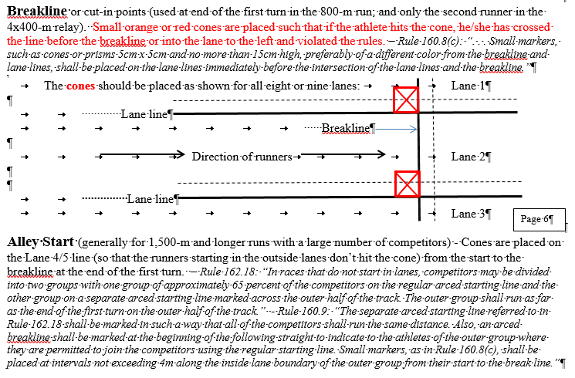

Placements of Hurdles Relative to Track Markings
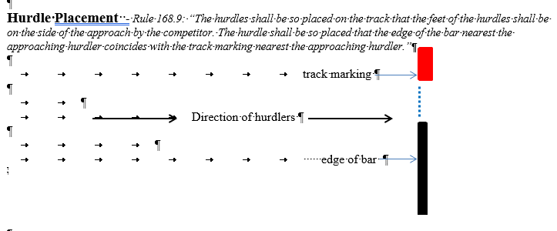

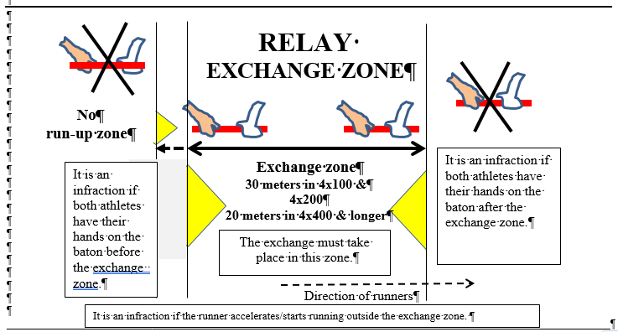
With water jump opposite the finish line, the
3000-meter has hurdles C & D removed at the start then put in place after the athletes pass; A = first (longest) hurdle; no water jump on the first pass.

The 2000-meter has A & B removed at start; C = first (longest) hurdle; water jump every lap.
Finish
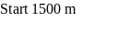
Start 3000 m Steeplechase
Start 2000 m
Water
Jump
STEEPLECHASE
2
1
5
3
4
6
7
8
9
10
11
12
start
start
#1 moves to direct athletes to the water jump with green flag in right hand (signaling with red or yellow flag in left hand to not stay on the track).
A
B
C
D

USATF Rule 161.2. The 3000 Meter Steeplechase shall have 28 hurdle jumps and 7 water jumps. The 2000 Meter Steeplechase shall have 18 hurdle jumps and 5 water jumps. The 1500 Meter Steeplechase shall have 13 hurdles and 3 water jumps. There shall be five jumps per lap after the finish line has been passed for the first time. The water jump shall be the fourth if that is feasible. The jumps should be evenly distributed, i.e., the distance between the jumps shall be approximately one-fifth of the nominal length of the lap. Because of differences in track design and water jump placement, all steeplechase courses must be individually measured. Generally, only the start line will need to be adjusted. A diagram showing a typical configuration of the barriers on a 400m track with an interior water jump is shown in the figure above.

The first two hurdles are removed at the start. In the 2000-meter steeplechase, the water jump is made on each of the five laps. In the 3000-meter steeplechase, the first 200+/- meters (>200m when the water jump is on the inside of the track; <200m when the water jump is on the outside of the track) of the race has no hurdles and no water jump; the other seven full laps each have all four hurdles and the water.

In the 2000-meter, the water jump is the second obstacle. In the 3000-meter, the water jump is the fourth obstacle.

If the water jump is near the regular finish line (near Umpire 12 on the diagram above), establish a new finish line at or near the start line for the 200-meter race in Lane 1, and establish the start lines for the 2000-meter and 3000-meter steeplechase races accordingly.

