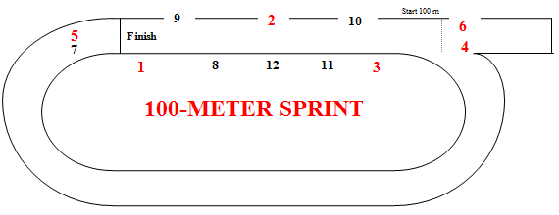

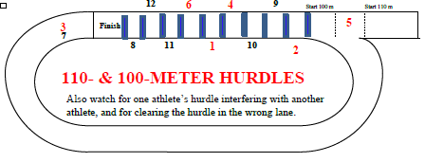

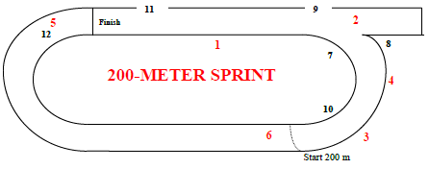

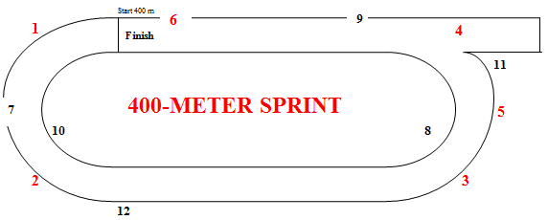

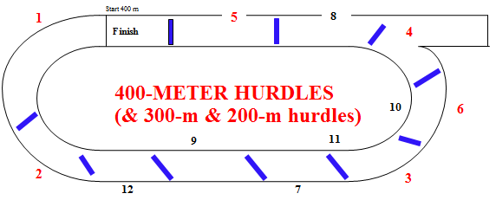

Umpires’ Positions
USATF-Pacific v.3May2018

Hurdle Infractions:
Foot or leg below top of hurdle (hooks hurdle) [168.3(a)] [SC 169.4(b)]
Didn’t jump each hurdle (ran around or hand pushed over) [168.3] [SC 169.4]
Deliberately knocked down hurdle [168.3(b)]
Didn’t stay in lane (interfered {with whom?} or shortened race) [168.3]
Stepped to one side or the other of water jump or SC hurdle [SC 169.4(a)]
Interference – who did it and who was impacted?
Jostled, ran across, or obstructed so as to impede another competitor [163.4]
Assistance – who provided it to whom? [144.2]
Pacing by persons not participating or lapped or about to be lapped [144.3(a)]
Possession or use by athlete of video, audio, or communication device [144.3(b)]
Aided by technology or appliance [144.3(c)] Personal assistance marker [163.2]
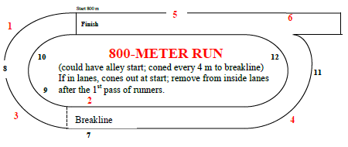

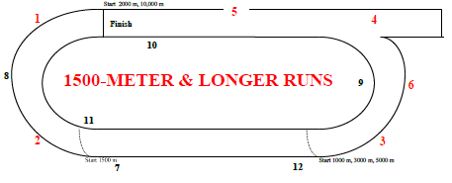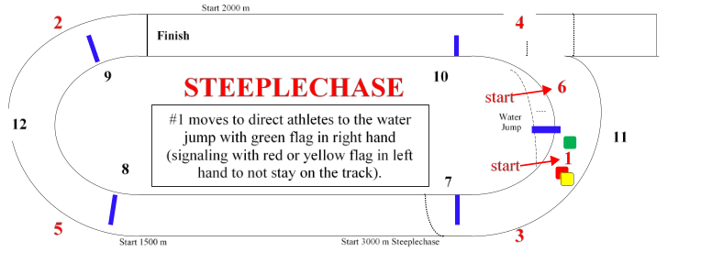

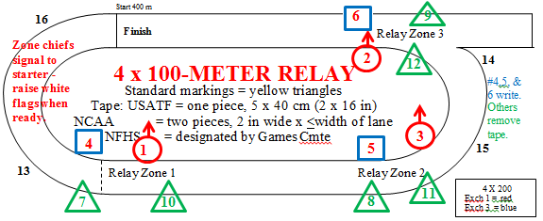
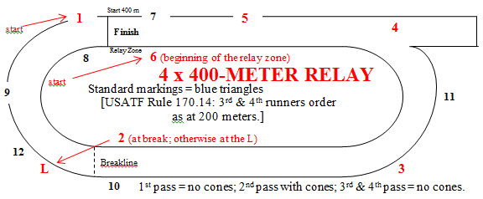
[Rule 170.5]

Lane Violations:
USATF: 1 step of either foot on or over inside line [163.5]
NCAA: 2 consecutive steps of any feet
NFHS: 3 consecutive steps of any feet
Cut in before breakline [163.5]
Did not finish in correct lane [163.5]
Relay Violations:
Exchanged baton before or after zone [170.17]
Accelerated before zone [170.13]
Incorrect recovery of dropped baton [170.16]
Impeded/did not maintain lane position [170.18]
Assisted outgoing runner by pushing [170.19]
Baton not carried by hand [170.16]
Failure to participate [142.3], except youth [302.2(g)]
Left track voluntarily and returned [163.6(a)] Unsporting conduct [125.10]

Umpires’ Positions
USATF-Pacific v.16Dec2019

Hurdle Infractions:
Foot or leg below top of hurdle (hooks hurdle) [168.3(a)] [SC 169.4(b)]
Didn’t jump each hurdle (ran around or hand pushed over) [168.3] [SC 169.4]
Deliberately knocked down hurdle [168.3(b)]
Didn’t stay in lane (interfered {with whom?} or shortened race) [168.3]
Stepped to one side or the other of water jump or SC hurdle [SC 169.4(a)]
Interference – who did it and who was impacted?
Jostled, ran across, or obstructed so as to impede another competitor [163.4]
Assistance – who provided it to whom? [144.2]
Pacing by persons not participating or lapped or about to be lapped [144.3(a)]
Possession or use by athlete of video, audio, or communication device [144.3(b)]
Aided by technology or appliance [144.3(c)] Personal assistance marker [163.2]

[Rule 170.5]

Lane Violations:
USATF: 1 step of either foot on or over inside line [163.5]
NCAA: 2 consecutive steps of any feet
NFHS: 3 consecutive steps of any feet
Cut in before breakline [163.5]
Did not finish in correct lane [163.5]
Relay Violations:
Exchanged baton before or after zone [170.17]
Accelerated before zone [170.13]
Incorrect recovery of dropped baton [170.16]
Impeded/did not maintain lane position [170.18]
Assisted outgoing runner by pushing [170.19]
Baton not carried by hand [170.16]
Failure to participate [142.3], except youth [302.2(g)]
Left track voluntarily and returned [163.6(a)] Unsporting conduct [125.10]
Hurdle Placement and Height Comparison – Outdoor Meets

Organization/Age Group Distance Number Height To 1st Between Last to Finish
Standard color

MEN Order
Junior High 110 10 33” 13.72 m 9.14 m 14.02 m BLUE
High School 110 10 39” 13.72 m 9.14 m 14.02 m BLUE
NCAA, USATF 110 10 42” 13.72 m 9.14 m 14.02 m BLUE
Junior High 200 5 30” 50 m 35 m 10 m
High School 300 8 36” 45 m 35 m 10 m
NCAA, USATF 400 10 36” 45 m 35 m 40 m
NCAA, USATF 3000 SC 28 (7 water) 36” 5 jumps/lap after fin. line passed 1st time; water jump 4th BLACK
Boys 11-12 80 8 30” 12 m 7.5 m 15.5 m #8
Boys 13-14 100 10 33” 13 m 8.5 m 10.5 m YELLOW #5
Boys 15-16/Men 17-18 110 10 39” 13.72 m 9.14 m 14.02 m BLUE #1,2
Boys 13-14 200 5 30” 20 m 35 m 40 m
Boys 15-16/Men 17-18 400 10 36” 45 m 35 m 40 m
Boys 15-16/Men 17-18 2000 SC 18 (5 water) 36” 5 jumps/lap after fin. line passed 1st time; water jump 4th BLACK
MASTERS MEN
30-49 110 10 39” 13.72 m 9.14 m 14.02 m
50-59 100 10 36” 13 m 8.5 m 10.5 m
60-69 100 10 33” 12 m 8 m 16 m
70-79 80 8 30” 12 m 7 m 19 m
80+ 80 8 27” 12 m 7 m 19 m
30-49 400 10 36” 45 m 35 m 40 m
50-59 400 10 33” 45 m 35 m 40 m
60-79 300 7 30” 50 m 35 m 40 m (same locations as 400)
80+ 200 5 27” 20 m 35 m 40 m (same locations as 400)
30-59 3000 SC 28 (7 water) 36” 5 jumps/lap after fin. line passed 1st time; water jump 4th BLACK
60+ 2000 SC 18 (5 water) 30” 5 jumps/lap after fin. line passed 1st time; water jump 4th BLACK
__________________________________________________________________________________________________

Organization/Age Group Distance Number Height To 1st Between Last to Finish Standard Color

WOMEN Order
Junior High 100 10 30” 13 m 8.5 m 10.5 m
High School 100 10 33” 13 m 8.5 m 10.5 m
NCAA, USATF 100 10 33” 13 m 8.5 m 10.5 m
Junior High 200 5 30” 50 m 35 m 10 m
High School 300 8 30” 45 m 35 m 10 m
NCAA, USATF 400 10 30” 45 m 35 m 40 m
NCAA, USATF 3000 SC 28 (7 water) 30” 5 jumps/lap after fin. line passed 1st time; water jump 4th BLACK
Girls 11-12 80 8 30” 12 m 7.5 m 15.5 m #7
Girls 13-14 100 10 30” 13 m 8 m 15 m red tape #6
Girls 15-16/Women 17-18 100 10 33” 13 m 8.5 m 10.5 m YELLOW #3,4
Girls 13-14 200 5 30” 20 m 35 m 40 m
Girls 15-16/Women 17-18 400 10 30” 45 m 35 m 40 m
Girls 15-16/Women 17-18 2000 SC 18 (5 water) 30” 5 jumps/lap after fin. line passed 1st time; water jump 4th BLACK
MASTERS WOMEN
30-39 100 10 33” 13 m 8.5 m 10.5 m
40-49 80 8 30” 12 m 8 m 12 m
50-59 80 8 30” 12 m 7 m 19 m
60+ 80 8 27” 12 m 7 m 19 m
30-49 400 10 30” 45 m 35 m 40 m
50-59 300 7 30” 50 m 35 m 40 m (same locations as 400)
60-69 300 7 27” 50 m 35 m 40 m (same locations as 400)
70+ 200 5 27” 20 m 35 m 40 m (same locations as 400)
All ages 2000 SC 18 (5 water) 30” 5 jumps/lap after fin. line passed 1st time; water jump 4th BLACK
[from USATF Best Practices]
———————————————————————————————————————————————————————————————————————————————————————————————————————————————————————————————————————
Hurdle Placement and Height Comparison – Indoor Meets

Organization/Age Group Distance Number Height To 1st Between Last to Finish
MEN
USATF 50 4 42” 13.72 m 9.14 m 8.86 m
High School 55 5 39” 13.72 m 9.14 m 4.72 m
NCAA, USATF 55 5 42” 13.72 m 9.14 m 4.72 m
NCAA, USATF 60 5 42” 13.72 m 9.14 m 9.72 m
BOYS YOUTH USATF
Boys 11-12 50 4 30” 12 m 7.5 m 15.5 m
Boys 11-12 55 5 30” 12 m 7.5 m 13.0 m
Boys 11-12 60 5 30” 12 m 7.5 m 18.0 m
Boys 13-14 33”
Boys 15-16/Men 17-18 39”
MASTERS MEN
30-49 60 5 39” 13.72 m 9.14 m 9.72 m
50-59 60 5 36” 13.00 m 8.50 m 13.00 m
60-69 60 5 33” 12.00 m 8.00 m 16.00 m
70-79 60 5 30” 12.00 m 7.00 m 20.00 m
80+ 60 5 27” 12.00 m 7.00 m 20.00 m

Hurdle Placement and Height Comparison – Indoor Meets

Organization/Age Group Distance Number Height To 1st Between Last to Finish
WOMEN
USATF 50 4 33” 13 m 8.5 m 11.5 m
High School 55 5 33” 13 m 8.5 m 8 m
NCAA, USATF 55 5 33” 13 m 8.5 m 8 m
NCAA, USATF 60 5 33” 13 m 8.5 m 13 m
GIRLS YOUTH USATF
Girls 11-12 50 4 30” 12 m 7.5 m 15.5 m
Girls 11-12 55 5 30” 12 m 7.5 m 13.0 m
Girls 11-12 60 5 30” 12 m 7.5 m 18.0 m
Girls 13-14 30”
Girls 15-16/Women 17-18 33”
MASTERS WOMEN
30-39 60 5 33” 13 m 8.5 m 13 m
40-49 60 5 30” 12 m 8 m 16 m
50-59 60 5 30” 12 m 7 m 20 m
60+ 60 5 27” 12 m 7 m 20 m
———————————————————————————————————————————————————————————————————————————————————————————————————————————————————————————————————————
Hurdle Placement and Height Comparison – Indoor Meets

Organization/Age Group Distance Number Height To 1st Between Last to Finish

MASTERS MEN
30-49 60 5 39” 13.72 m 9.14 m 9.72 m
50-59 60 5 36” 13.00 m 8.50 m 13.00 m
60-69 60 5 33” 12.00 m 8.00 m 16.00 m
70-79 60 5 30” 12.00 m 7.00 m 20.00 m
80+ 60 5 27” 12.00 m 7.00 m 20.00 m

MASTERS WOMEN
30-39 60 5 33” 13 m 8.5 m 13 m
40-49 60 5 30” 12 m 8 m 16 m
50-59 60 5 30” 12 m 7 m 20 m
60+ 60 5 27” 12 m 7 m 20 m
———————————————————————————————————————————————————————————————————————————————————————————————————————————————————————————————————————

Placements of Cones at the Breakline and for Alley Starts

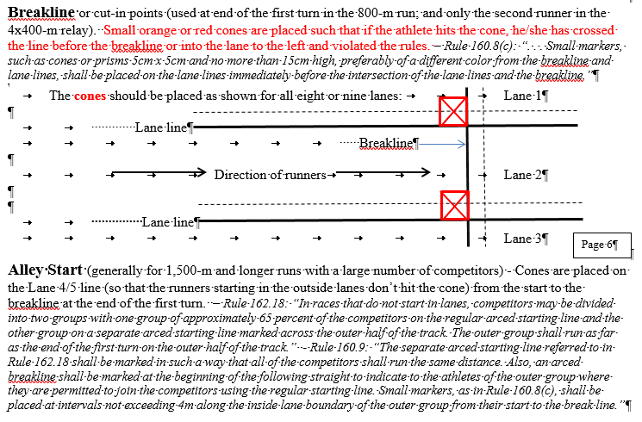

Placements of Hurdles Relative to Track Markings
